Title
Name and Affiliation of Authors

The content of the abstract can be of any length between 100 to 500 words in Chinese or English, depending on the number of pictures attached. The abstract can include but not obliged to the followings: keywords, description of the content and scope of the project, identification of the project’s objective, methodology and the research findings, conclusions or intended results.

The format could include articles, tables and graphs. The preferred length of the whole abstract should be within one A4 page (CV included).

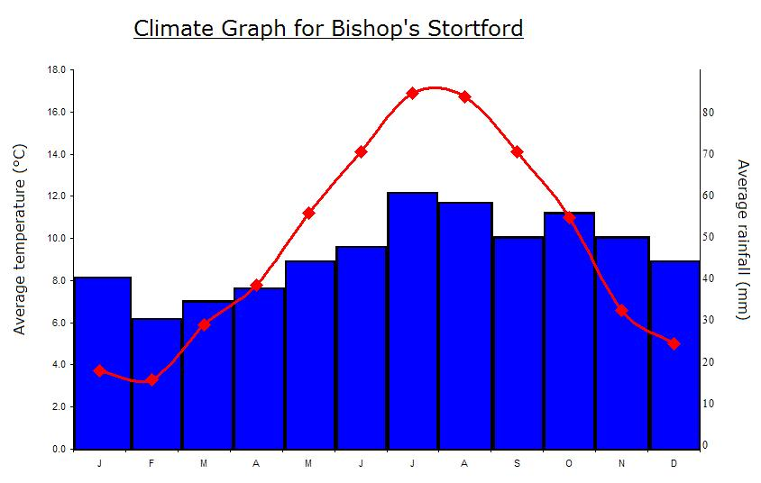
This Photo by Unknown Author is licensed under CC BY-SA

Reference:

A brief CV states the author’s background, research interest, email (phone) address, sponsored organization, etc.

